Customer Data Analysis Using Power BI

Project Overview
This project analyzes customer shopping behavior using Power BI dashboards and interactive visualizations to identify sales trends, customer preferences, and business performance. The project supports data-driven decision-making through interactive dashboards, KPIs, and business visualizations.

Project Objectives
- Analyze customer purchasing behavior.
- Evaluate revenue across gender, age groups, product categories, shopping malls, and payment methods.
- Create interactive Power BI dashboards.
- Provide business insights and strategic recommendations.

Dataset Overview
The dataset includes customer transactions such as Invoice Number, Customer ID, Gender, Age Group, Product Category, Quantity, Revenue, Payment Method, and Shopping Mall. Data was cleaned and transformed using Power Query before visualization.

Dashboard Development
Power BI visuals such as KPI Cards, Bar Charts, Column Charts, Pie Charts, Treemaps, and Slicers were used to develop interactive dashboards for analyzing customer purchasing behavior and business performance.

Analysis Performed

Customer Purchase Analysis
KPIs such as Total Orders, Total Revenue, Quantity Sold, Unique Customers, and Average Order Value were analyzed.

Gender Analysis
Customer purchases, product sales, and revenue were compared across gender segments to identify purchasing patterns.

Product Category Analysis
Revenue and quantity sold were evaluated across product categories to identify top-performing categories.

Age Group Analysis
Revenue, order count, and product sales were analyzed across different age groups to identify the most valuable customer segment.

Payment Method Analysis
Payment preferences and revenue contribution by payment method were examined.

Sales Performance Analysis
Sales performance across different shopping malls was analyzed to identify high-performing and low-performing locations.

Key Business Insights
- Female customers contributed a larger share of revenue.
- High-performing product categories generated the majority of sales.
- The leading age group contributed the highest orders and revenue.
- Cash was a preferred payment method.
- Shopping mall performance varied across locations.
- Interactive dashboards simplified business monitoring.
- The dashboard enables quick identification of customer trends and supports effective business decision-making.

Strategic Recommendations
Based on the data analysis findings, the following strategic actions are recommended to improve business performance and customer satisfaction:
- Strengthen customer retention programs.
- Optimize inventory for high-demand categories.
- Use targeted marketing campaigns.
- Encourage digital payment adoption.
- Improve low-performing shopping mall sales.
- Continuously monitor KPIs using Power BI.

Conclusion
The project successfully demonstrated how Power BI can transform raw customer transaction data into meaningful business insights. The dashboards highlighted customer behavior, sales trends, and revenue patterns, enabling informed and data-driven business decisions. Overall, the project showcases the effectiveness of Power BI as a business intelligence tool for analyzing customer data, improving business performance, and supporting strategic planning.

- How is the shopping distribution according to gender?
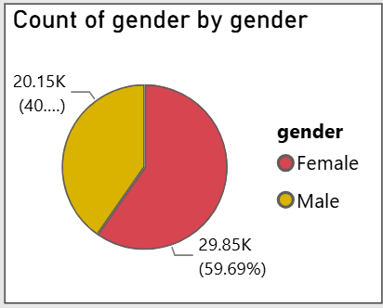

- Which gender did we sell more products to?
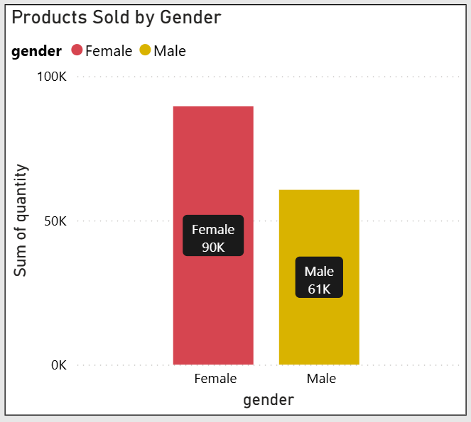

- Which gender generated more revenue?

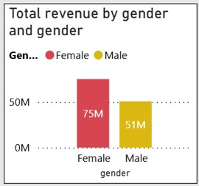

- Distribution of purchase categories relative to other columns?

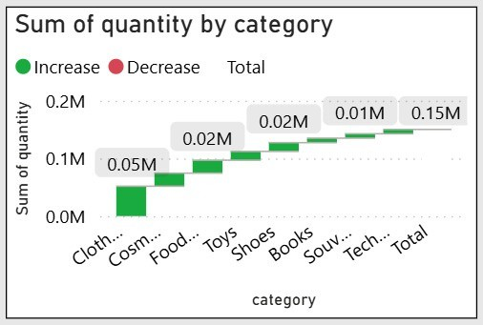

- How is the shopping distribution according to age?

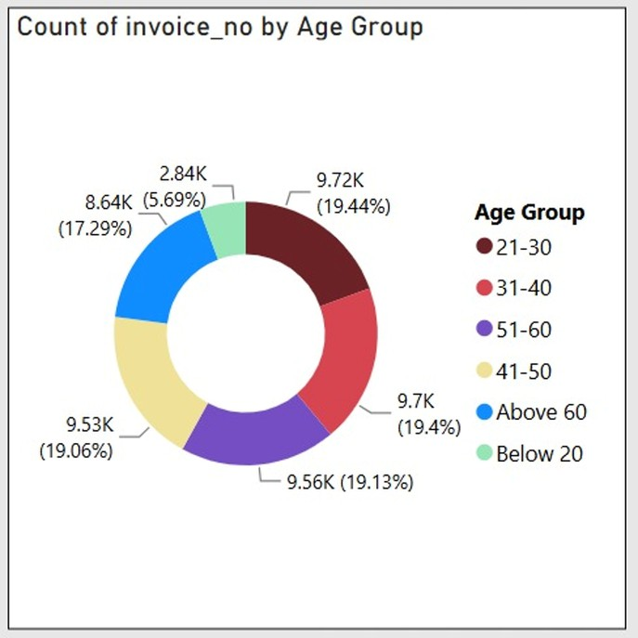

- Which age cat did we sell more products to?

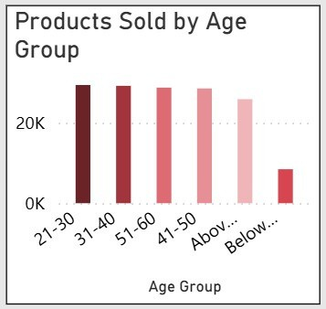

- Which age cat generated more revenue?

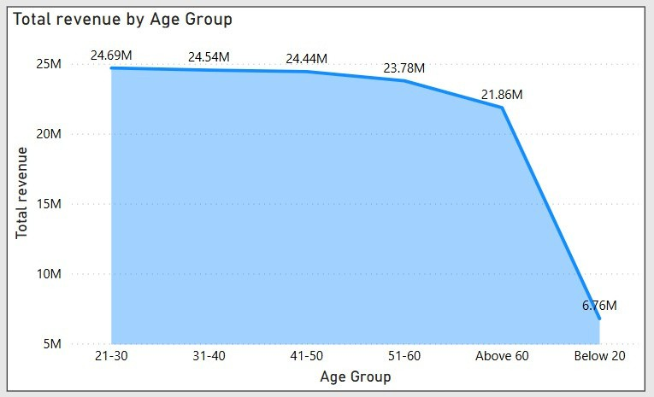

- Distribution of purchase categories relative to other columns?

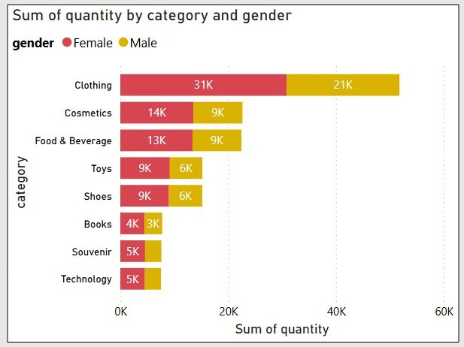

- Does the payment method have a relation with other columns?

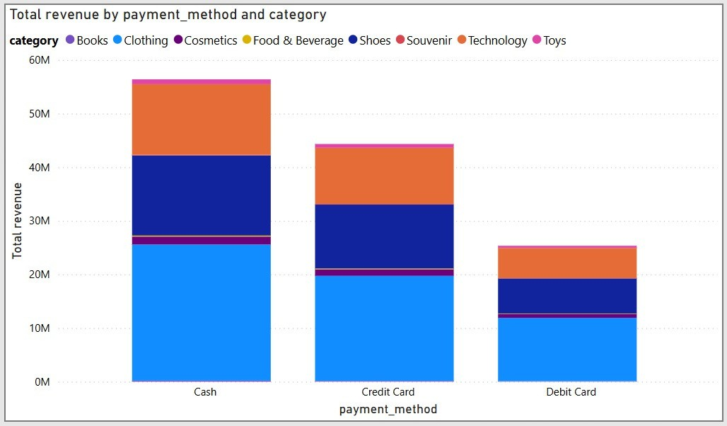

- How is the distribution of the payment method?

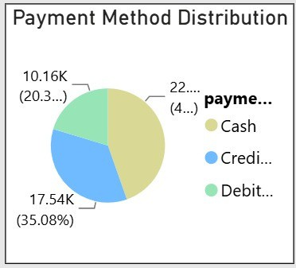

- Visualize the data using Tableau /PowerBI and derive insights and give your inputs/suggestions to the company.

